DRS4 Evaluation Board

Instructions for use of DRS Oscilloscope program and DRS Data Analysis Program

Fermi-lab Scintillator Detector Development Group

Lab 6 – Darkroom setup

Written 8/10/2016

Last revised: 8/11/2016

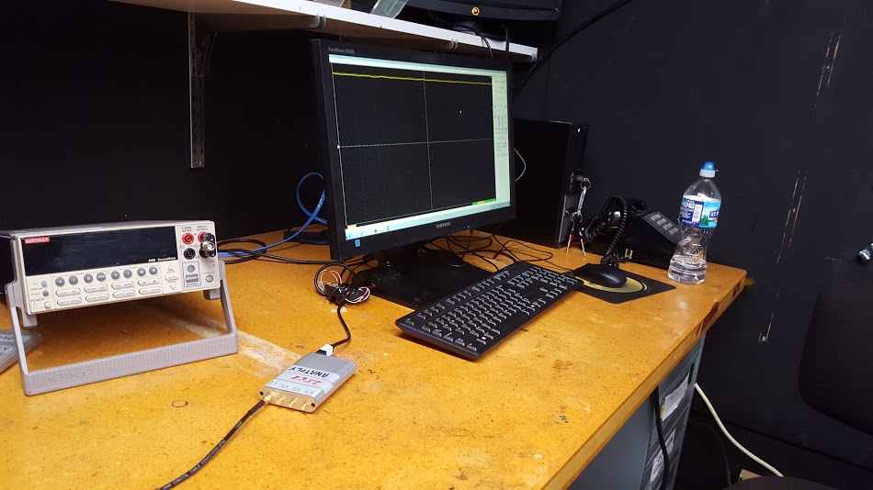

Christopher Settles

Waubonsee Community College

Fermilab Summer Intern, Community College Internships (CCI) Program

[csettles@student.waubonsee.edu](mailto:csettles@student.waubonsee.edu) ChristohperRSettles@gmail.com

# Installing Software for use on other devices

There is some software that will need to be installed in order to take advantage of this application. Those two applications are:

Root version: 34.36 – The visual studio 2013 version - <https://root.cern.ch/content/release-53436> -

* Ensure ROOT is added to the system path for at least the user who intended on using the application, if not all users.
  + One can do this by going to My computer->Properties->Advanced System Settings->Environment variables->System Variables->Path->Edit-> Ensure C:\root_v5.34.36\bin has been added.
* Install root directly on the system root C:\\

DRS Oscilloscope software version: 5.05

<https://www.psi.ch/drs/software-download> - Download the Proper Installer

The source code for this project can be found here:

<https://github.com/ChristopherRSettles/DRS4-Data-Analysis-Interface>

There are also some files that you will need to transfer onto the other PC from the github repository.

>Transfer the entire “DRSDataAnalysis” folder onto the system root C:\\

>From the C:\DRSDataAnalysis\Macros folder, copy the Integration.C and Integration.h files into the C:\root_v5.34.36\macros folder.

If desired, create a shortcut for the Data analysis batch file on the desktop by:

Right Click on desktop->New Shortcut->Navigate to C:\DRSDataAnalysis\DRS_Projects and select the batch file->Name it “DRS Data Analysis”

# Using the Programs

Simply double clicking on the “DRS Oscilloscope” icon will open the Oscilloscope program and double clicking on the “DRS Data Analysis” icon will open the Data Analysis program.

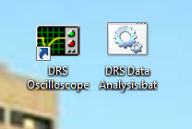

# Use of DRS Oscilloscope program

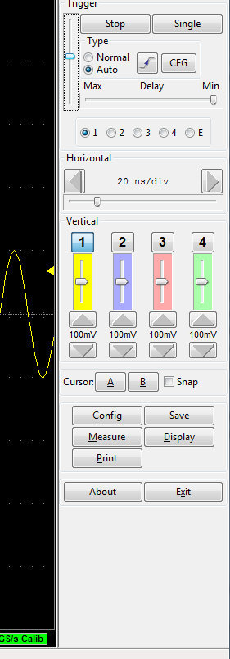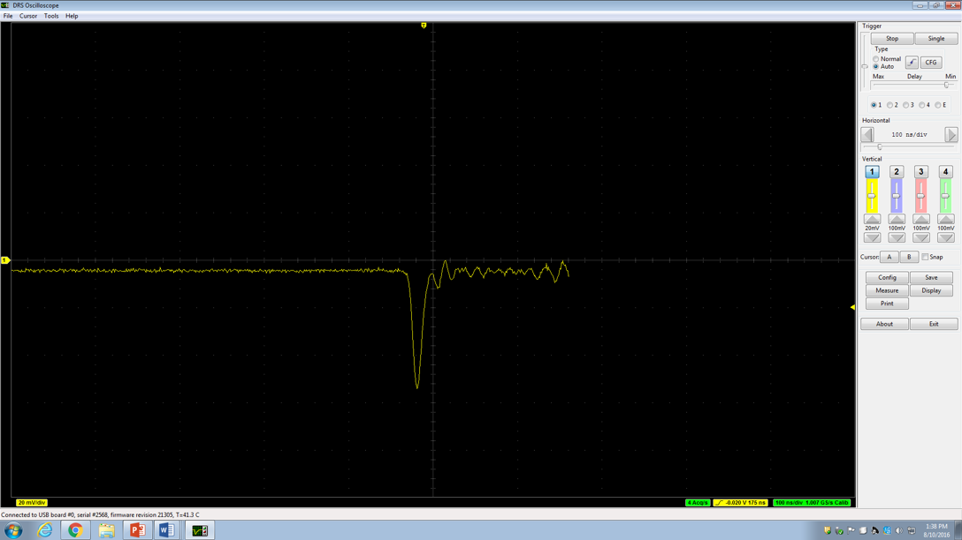 The DRS4 Installer installs both a command line way of taking data and a Graphical way of retrieving data. This documentation will focus on the graphical way of retrieving data. The DRS module takes advantage of up to 4 channels, but for our purposes we will only be taking advantage of the first channel. The other 3 channels are relatively useless in this current setup. Do not use the 2, 3, or 4 channel controls.

A signal produced in the oscilloscope program that needs to be recorded.

There are some controls to familiarize oneself with for the DRS oscilloscope program

1. 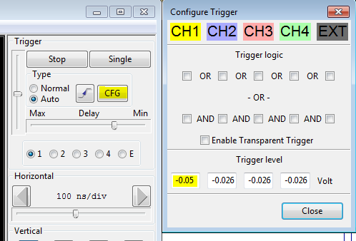Trigger level: setting the trigger threshold allows the oscilloscope to only grab events that have a charge greater than that threshold. Setting a high trigger will ensure that only events with higher charge get recorded / displayed. It is also important to note that only data sets with the same trigger value can be compared. If you want to ensure that the trigger is the same run to run, you can set the trigger level to be the same for each run. (As seen in figure). One can do this by clicking **CFG,** then inserting a proper trigger value in the CH1 trigger on the bottom. The trigger level should be set at least twice as high as the noise level. The trigger is show on the oscilloscope as the yellow triangle on the right of the graph.
2. **Delay** time: Since the oscilloscope shows a graph of time on the x-axis and charge on the y-axis, and time is 0 at the left end of the wave. By setting the delay time, the trigger will detect the high amplitude wave and then have a little bit of a delay in time before that wave is displayed to the screen and/or recorded. (As shown above)
3. **Horizontal / Vertical Scaling**: The arrows will shrink the wave and the scroll bar will allow you to view the different parts of the wave.
4. 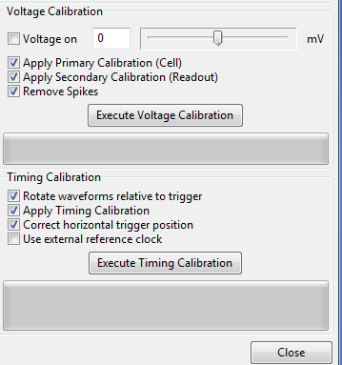**Config** – it is always important to execute a timing calibration. It is also recommended to execute a voltage calibration but only after the DRS has warmed up. When executing the voltage calibration, it is also important to remember to disconnect any input signals coming into the DRS before hitting execute. Executing the calibration is only necessary when the DRS hasn’t been used for some time (probably around 5 or 6 hours).

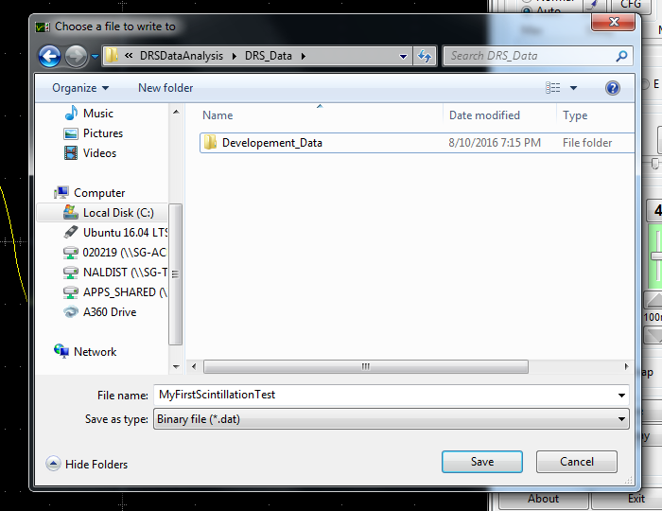

1. Saving – When the user wishes to take the data,

* Click File -> Save…
* Change the Save as type to “Binary file(*.dat)”
* Select a file name and appropriate file location. The file path must not contain any spaces in it, only underscores. Same with the file name.
* Click save
* 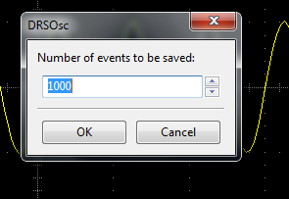The number of events you tell it to save is the number of runs that that is desired in order to achieve a comfortable accuracy. Generally, taking 1000 events is good unless the data is coming very slowly. When all events have been saved the oscilloscope will report the number of events saved at the bottom.

# Use of DRS Data Analysis Program

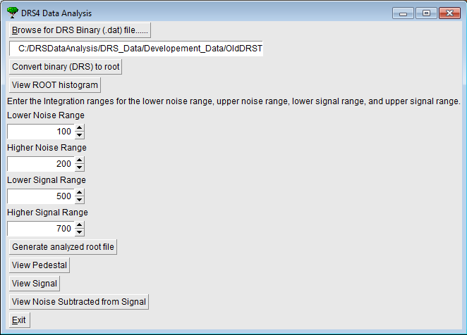

There are also a few controls to be said about the data analysis program. This system works with ROOT, a data analysis framework developed by CERN.

1. The first step for the user is to select the binary file that is desired to analyze. This should be the one that was just saved if you are coming directly from the oscilloscope program.
2. Click the convert binary to ROOT button. This will generate the root file in the same directory that the binary file is in.
3. Click View ROOT histogram. This will display an overlay of every event that was recorded and lay them all on top of one another so that the user can see how things generally happen.

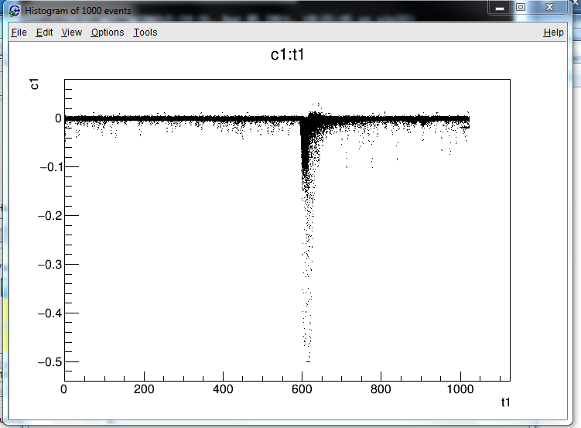

1. The User should now be able to see a histogram with a large signal and other flatter areas. The user can enter in the areas that a good sample of the noise could come from and also an area where a good sample of the signal can come from. After entering in these values, the user can Generate the root file. The ranges should include 100-200 data points. (Ex: 550-750 or 200-300)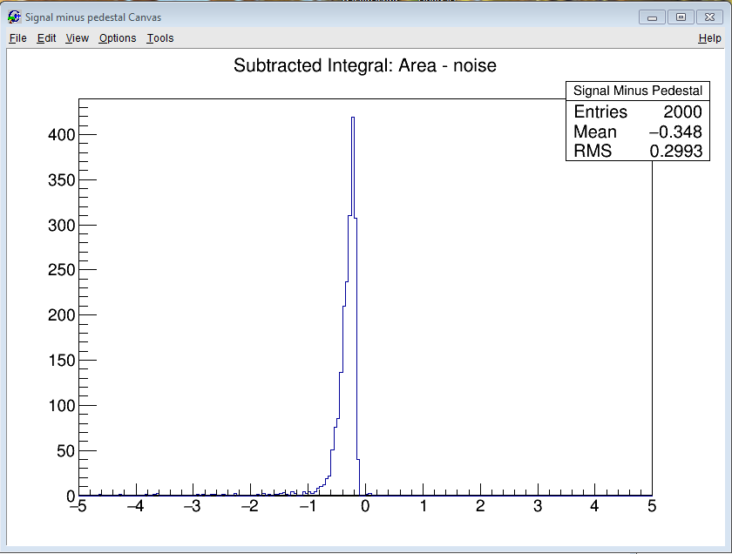

Example

Noise

Range

Example

Signal

Range

1. The View buttons will display a distribution of the integrated charge for the number of events. The mean of the distribution would be considered as the actual location of that distribution. The Noise subtracted from Signal button will provide the user with an idea of how much integrated charge the photodetector detected. Or if a scintillator is being tested, how much light came out of the scintillator.

The plot that is shown is the distribution of the events for whichever graph was selected. So for the graph above, the plot represents a peak at about -0.3 going up to 400. This means that the Signal area was integrated for 2000 events and about 400 of those 2000 events had a voltage of about -0.3.

1. Using the exit button when finished will help prevent against things freezing from just closing the entire application out. If at any time the program freezes, just exit out and open it up again. No data will be lost as a result of freezing due to the fact that the data can be regenerated from the .dat binary file.
2. The Analysis program takes the binary file and creates two root files. The root file is just named exactly what the binary file is named, and is essentially just a root compilation of the data inside of the binary file. This root file is what produces the compilation plot of the many events overlaid on top of one another.